# Executive Summary for TravelTide Customer Segmentation

## Introduction

As TravelTide seeks to improve customer retention in a competitive market, this analysis focuses on segmenting the customer base to align with a variety of travel perks offered in our rewards program.

## Objectives

* To identify distinct customer segments within TravelTide's user base.
* To align these segments with tailored travel perks in TravelTide's rewards program for enhanced customer retention.

## Methodology

The analysis was conducted using Jupyter Notebooks with Python for data manipulation and SQL for initial data extraction. A Vincenty formula was implemented as a more accurate alternative to the Haversine distance function for calculating geographical distances. Google Maps and API Ninja APIs were utilized to verify and update location information. The data was sourced from the TravelTide database.

## Key Findings

### Exclusive Discounts: The High Value Travelers

This segment comprises of 781 customers with an average spend of $11,511 over their lifetime with TravelTide. These are the top 15% of customers, by spend during the cohort period. This segment contributes significantly to revenue and should be the focus of high-value perks within the loyalty program. This segment would likely respond well to the introduction of a premium membership tier within the rewards program.

### Free Hotel Meal: The Planner's Choice

This segment focuses on travelers who booked well in advance, looking for the best value for tickets before any discounts. In addition, this segment also includes travelers with a 1-night stay. With an average booking value of $2,495 this segment is ideal for a perk that adds value without adding high costs. There are 416 travelers in this segment.

### Free Night Hotel Stay with Flight: The Long-Stay Guests

This segment is travelers who have booked trips that are 4 nights or longer. This segment would respond well to having a free night perk and would be a good target for upsells and additional services such as car rentals and theme park tickets with their extended stays. Over 800 travelers in this segment have had trips that are a week or longer. This is the largest segment at 2389 users with an average booking of $1,886.

### Lounge Access: The Global Traveler

With International Travel rebounding after the COVID-19 pandemic there are 96 travelers in the International Travel segment with an average booking of $2,261. Even though this is currently a small segment it will grow as more travelers are comfortable with international travel. Lounge access is relatively inexpensive compared to some other perks and gives these travelers a strongly desired perk and status symbol.

### Free Checked Bag: The Family and Group Segment

With 473 travelers, this segment includes travelers who are married and have kids, as well as travelers who booked trips with either 6 or more airplane seats or 3 or more hotel rooms. In the exploratory analysis it was found that every traveler that had a flight also checked a bag. This segment has an average booking of $1,085 making them the lowest average value segment. This is because there are several families who did not book trips during their visits to our site. Offering a free checked bag, which is a $30-$40 value in most cases, is a low-cost perk to use as an enticement for this group to have them not just book, but to become a long-term customer.

### Free Cancellation: The Flexible Traveler

There are 66 travelers in this segment, and this was the last segment created. There are 620 travelers who came to the site with the intention of canceling their trip. All 620 rebooked with us and led to most being included in other segments. Overall, the 66 travelers who remain for this segment have an average booking of $1,783 and one with a booking of over $6,900.

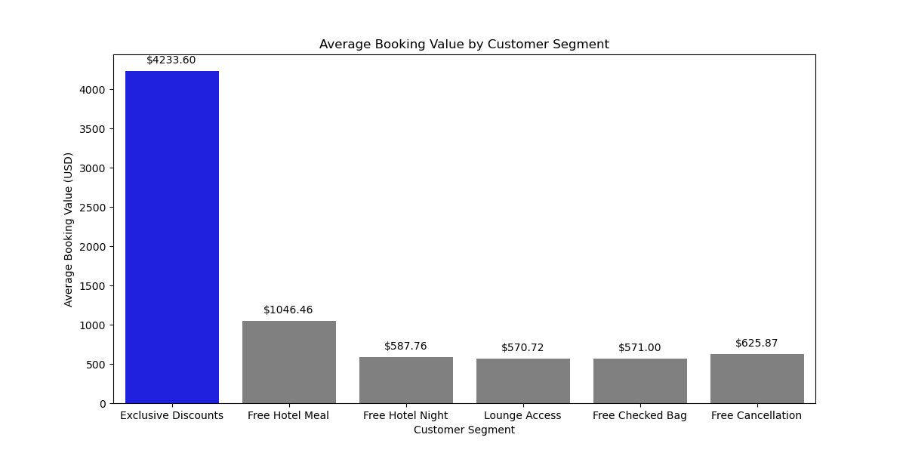

#### Figure 1: Average Booking Value by Segment

## Recommendations

### A/B Testing for Segment Validation

### Given the insights derived from the customer segments, it is recommended to conduct A/B testing to validate the effectiveness of targeted perks for each segment. Success will be measured by metrics such as conversion rates and customer engagement. A tentative timeline for this testing phase could be 4-6 weeks.

### Launch the Rewards Program

Using the provided segmentation data, launch the targeted email campaign. We can further refine the segments based on average spend, allowing us to target the highest value customers first. The success of this program will be evaluated based on KPIs like customer lifetime value and engagement rates.

### Resource Allocation and Risk Mitigation

Both initiatives will require dedicated manpower, a set budget, and technology resources. In case the initiatives do not meet the expected KPIs, a contingency plan will be in place for quick adjustments.

### Continuous Monitoring

Regular monitoring and reporting of KPIs will be essential for the ongoing optimization of the rewards program.